# EXPERIMENT NO. 01

**Aim:** To understand the benefits of Cloud Infrastructure and Setup AWS Cloud9 IDE, Launch AWS Cloud9 IDE and Perform Collaboration Demonstration.

# Theory:

AWS Cloud9 is a cloud-based integrated development environment (IDE) that lets you write, run,and debug your code with just a browser. It includes a code editor, debugger, and terminal. Cloud9comes prepackaged with essential tools for popular programming languages, including JavaScript,Python, PHP, and more, so you don’t need to install files or configure your development machine tostart new projects. Since your Cloud9 IDE is cloud-based, you can work on your projects from youroffice, home, or anywhere using an internet-connected machine. Cloud9 also provides a seamlessexperience for developing serverless applications enabling you to easily define resources, debug,and switch between local and remote execution of serverless applications. With Cloud9, you can quickly share your development environment with your team, enabling you to pair program real time.

# Benefits

CODE WITH JUST A BROWSER

AWS Cloud9 gives you the flexibility to run your development environment on a managed Amazon EC2 instance or any existing Linux server that supports SSH. This means that you can write, run, and debug applications with just a browser, without needing to install or maintain a local IDE. The Cloud9 code editor and integrated debugger include helpful, time-saving features such as code hinting, code completion, and step-through debugging. The Cloud9 terminal provides a browser-based shell experience enabling you to install additional software, do a git push, or enter commands.

CODE TOGETHER IN REAL TIME

AWS Cloud9 makes collaborating on code easy. You can share your development environment with your team in just a few clicks and pair program together. While collaborating, your team members can see each other type in real time, and instantly chat with one another from within the IDE.

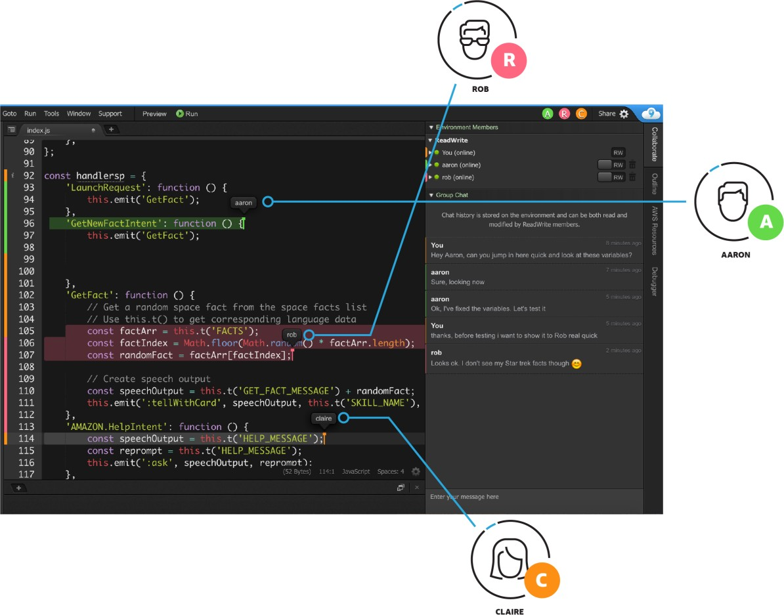

BUILD SERVERLESS APPLICATIONS WITH EASE

AWS Cloud9 makes it easy to write, run, and debug serverless applications. It preconfigures the development environment with all the SDKs, libraries, and plug- ins needed for serverless development. Cloud9 also provides an environment for locally testing and debugging AWS Lambda functions. This allows you to iterate on your code directly, saving you time and improving the quality of your code.

START NEW PROJECTS QUICKLY

AWS Cloud9 makes it easy for you to start new projects. Cloud9’s development environment comes prepackaged with tooling for over 40 programming languages, including Node.js, JavaScript, Python, PHP, Ruby, Go, and C++. This enables you to start writing code for popular application stacks within minutes by eliminating the need to install or configure files, SDKs, and plug-ins for your development machine. Because Cloud9 is cloud-based, you can easily maintain multiple development environments to isolate your project’s resources.

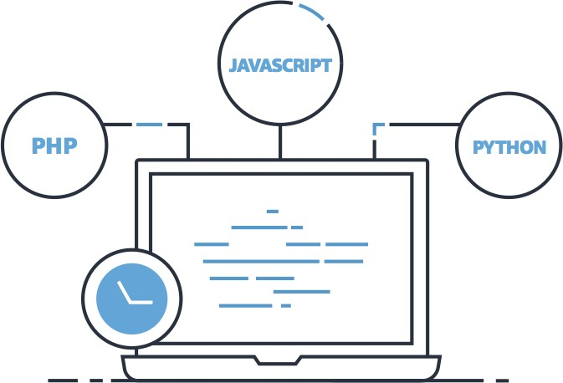

# Steps:

**Step 1: Create an AWS account**

**Click on the URL :** [**https://aws.amazon.com/console/**](https://aws.amazon.com/console/) **Create new AWS Account**

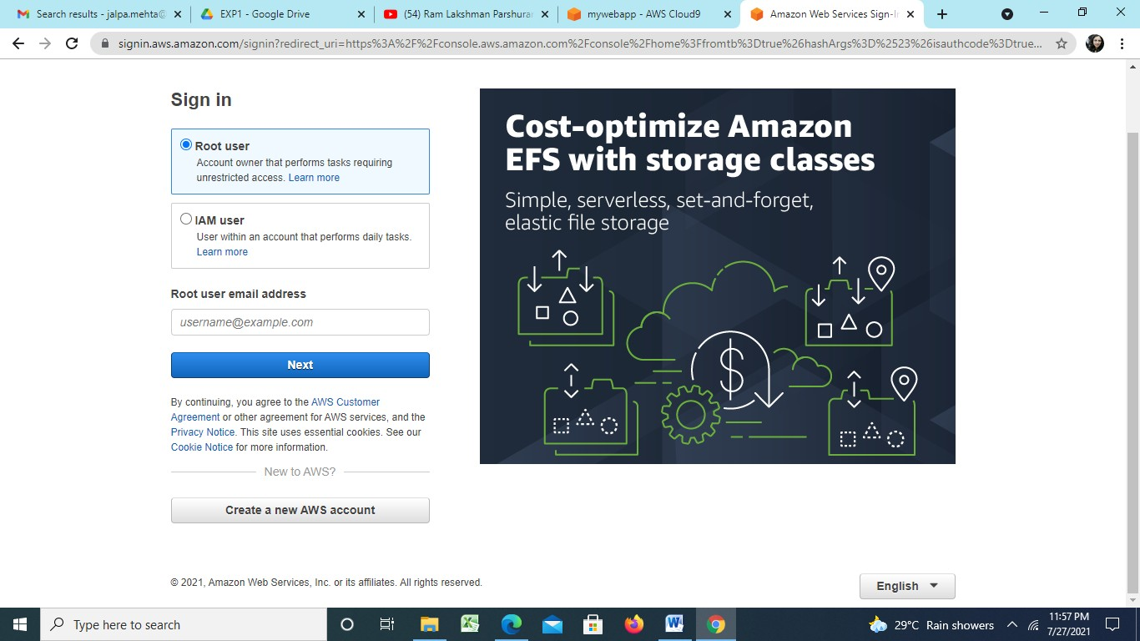

**Complete the AWS sign up process by filling account details.**

**Note: please keep record of AWS credentials and 12 digit account number**

**Step 2: Sign in to AWS root user by providing credentials and Go to My Account and select AWS Management Console.**

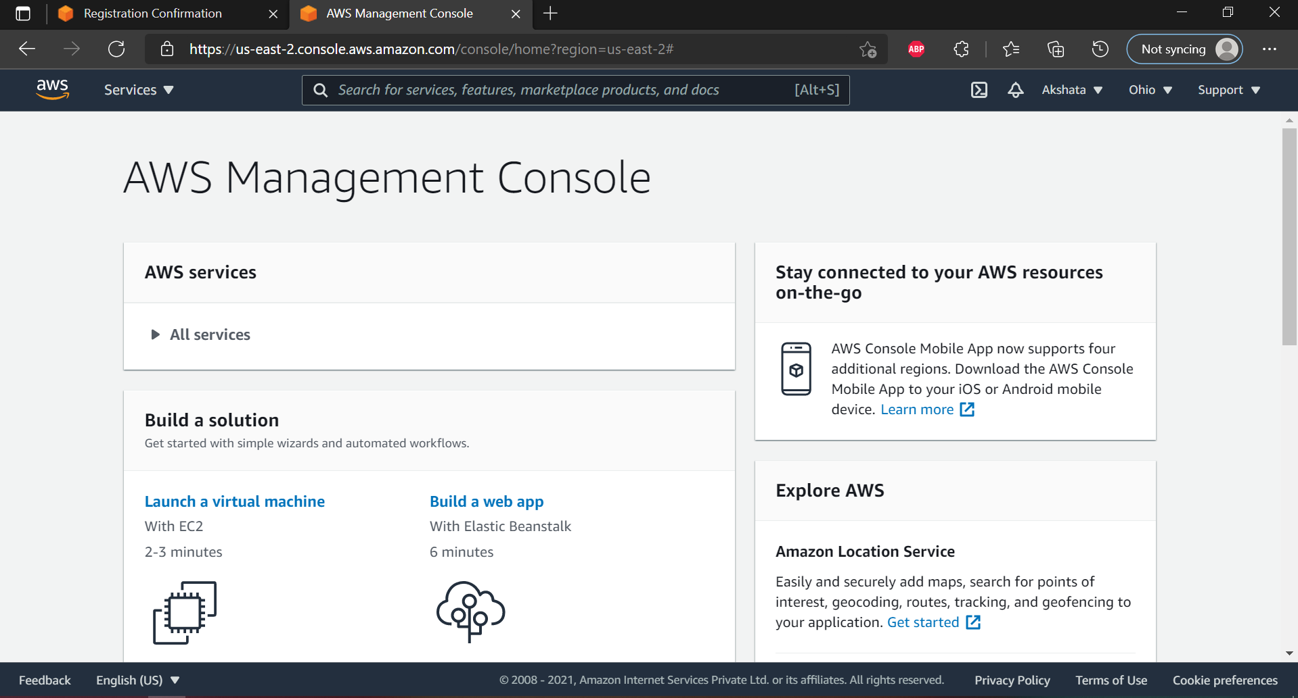

**Step 3: search for IAM service and go to IAM management console**

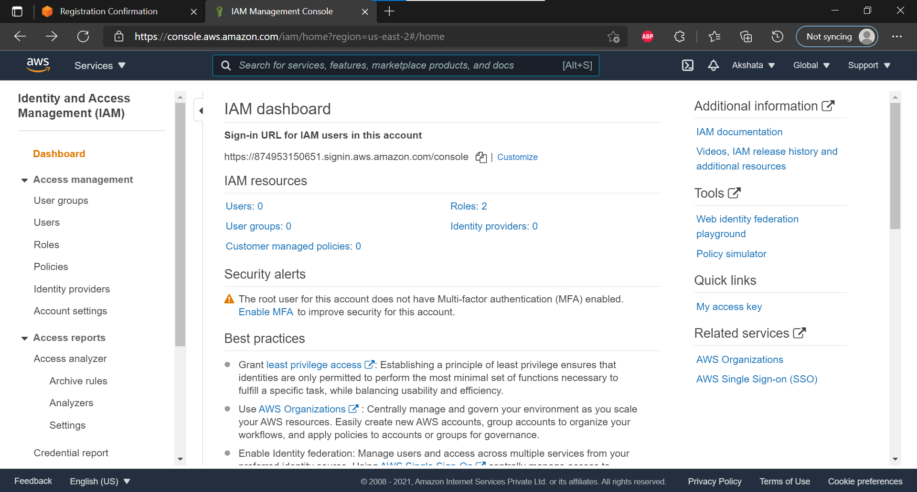

**Step 4: click on the user tab and add user**

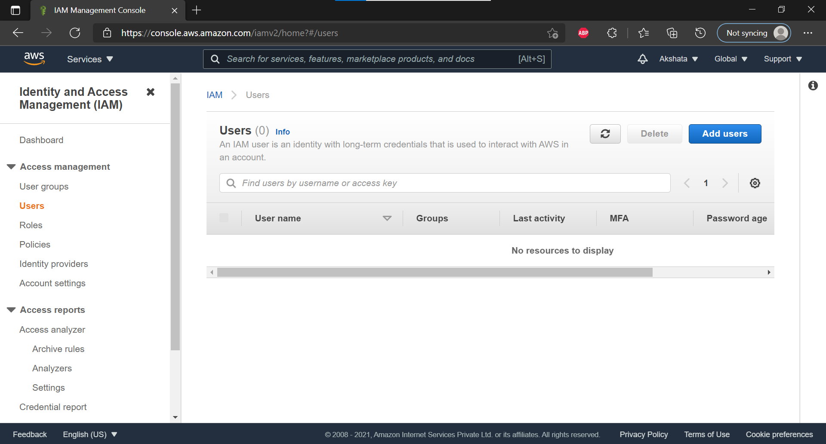

**Step 5: Provide user details. user name, select AWS access type as AWS Management Console Access and provide custom password.**

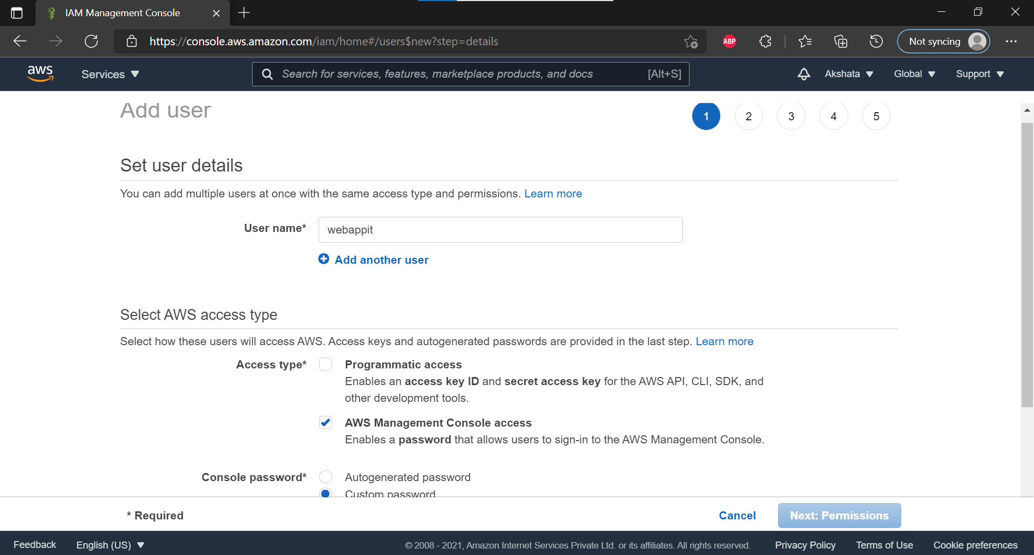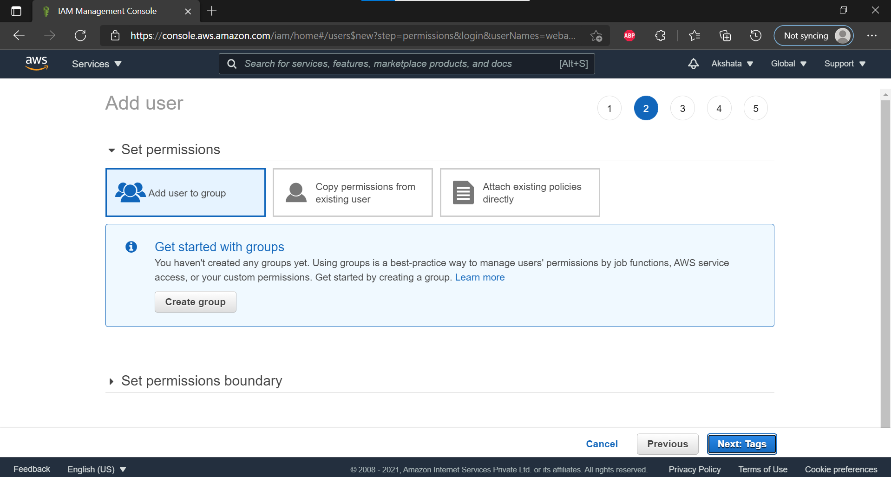

**Step 6: Create User Group**

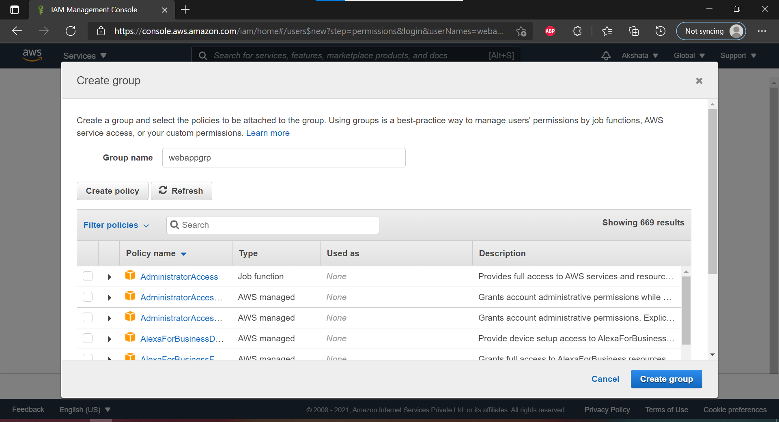

**Step 7: Review User Details**

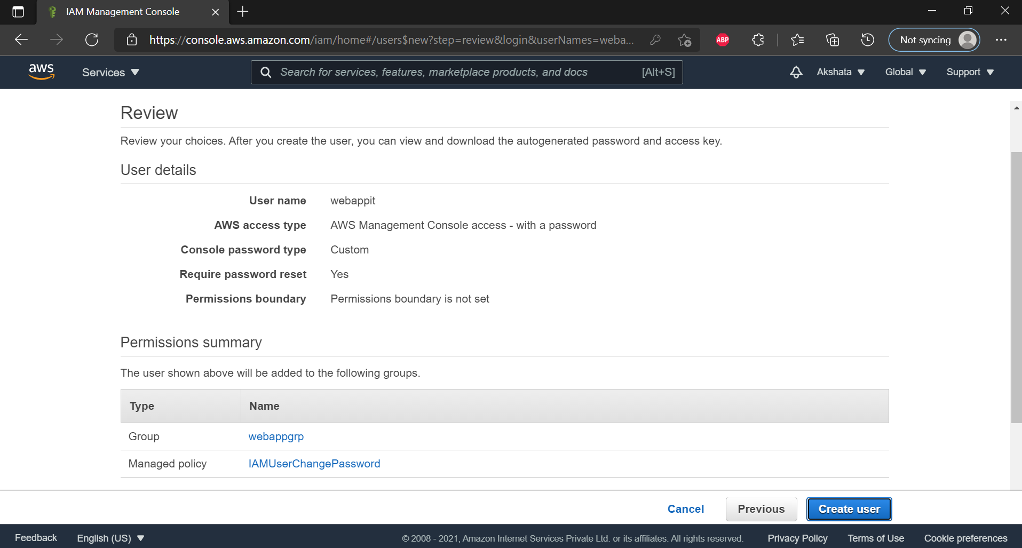

**Step 8: click on your group name which you have created and navigate to permission tab as shown in figure**

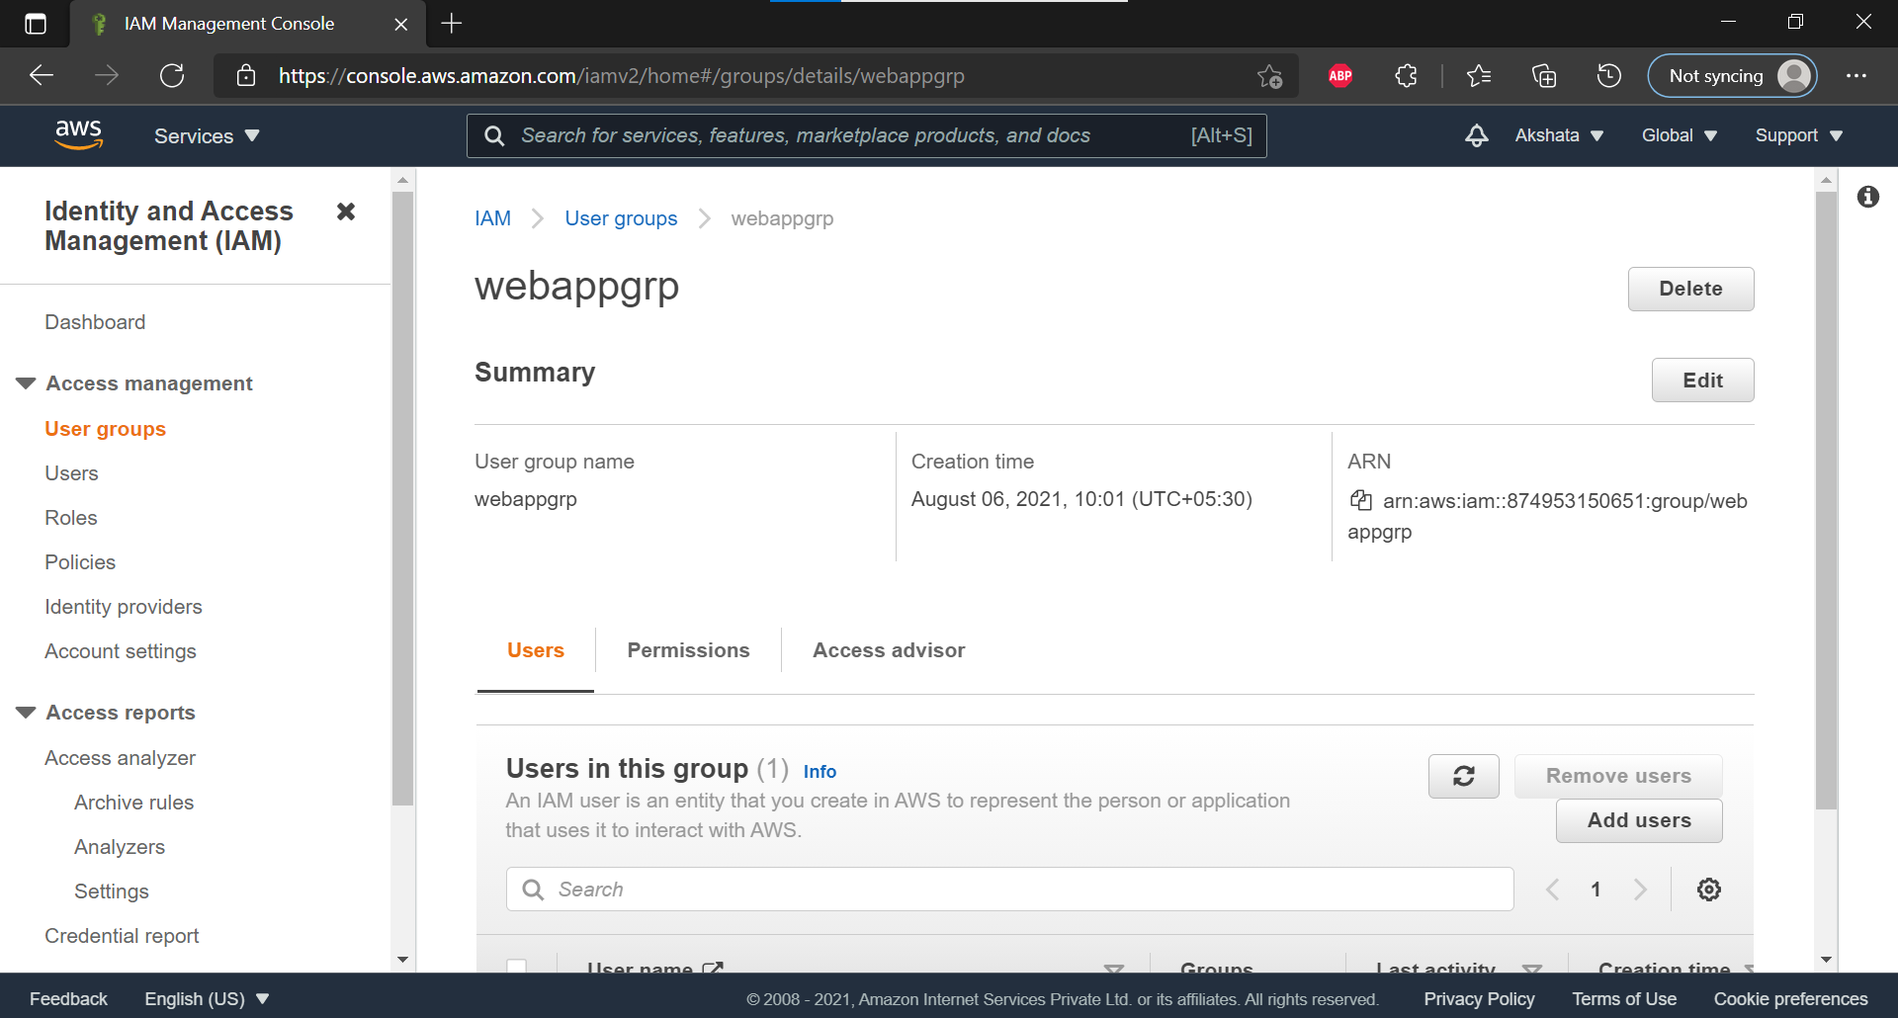

**Step 9: Now click on Add permission and select Attach Policy after that search for Cloud9 related policy and select Awscloud9EnviornmentMember policy , AWSCloud9Administrator and add it.**

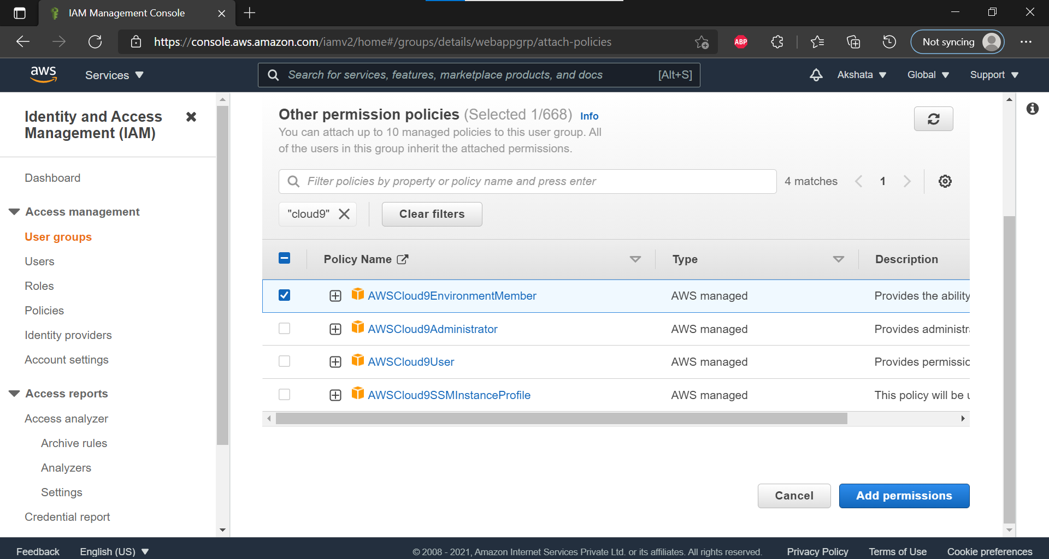

**Step 10: Go back to AWS management console and sign out the root account.**

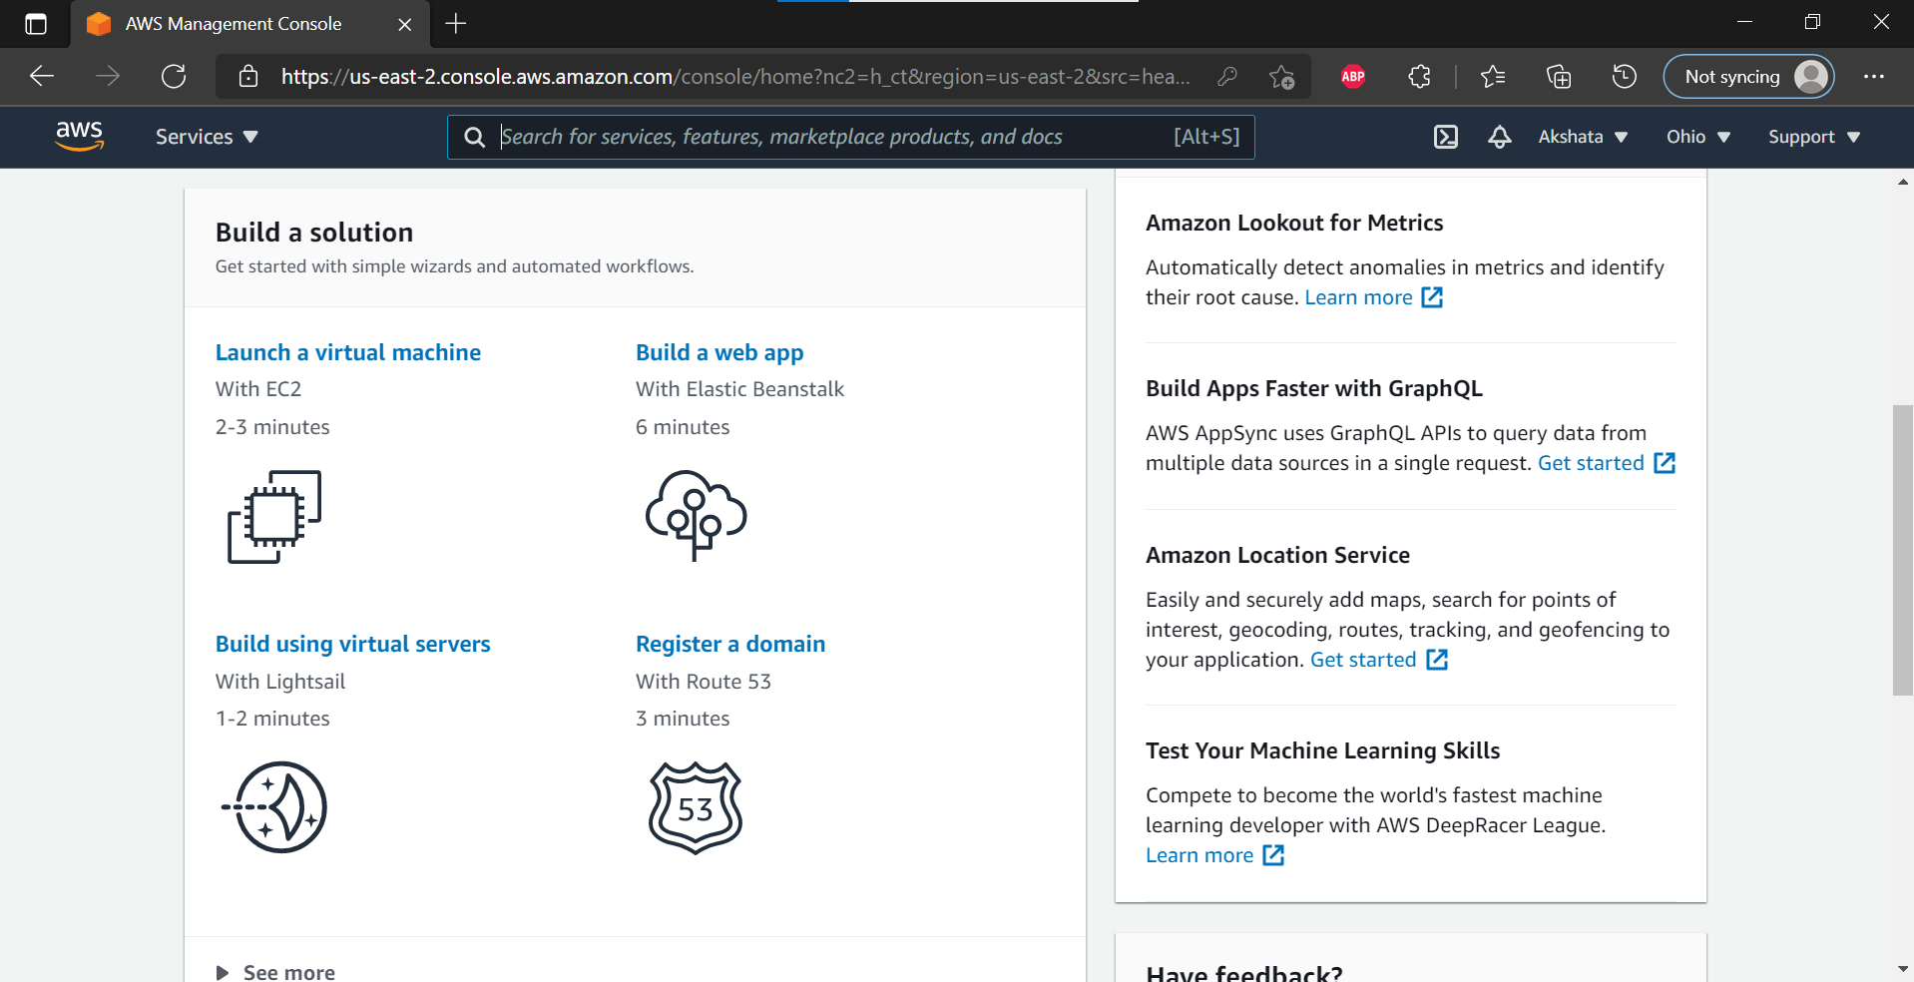

**Step 11: Sign in as IAM user created before by providing 12 digit Account ID and credentials.**

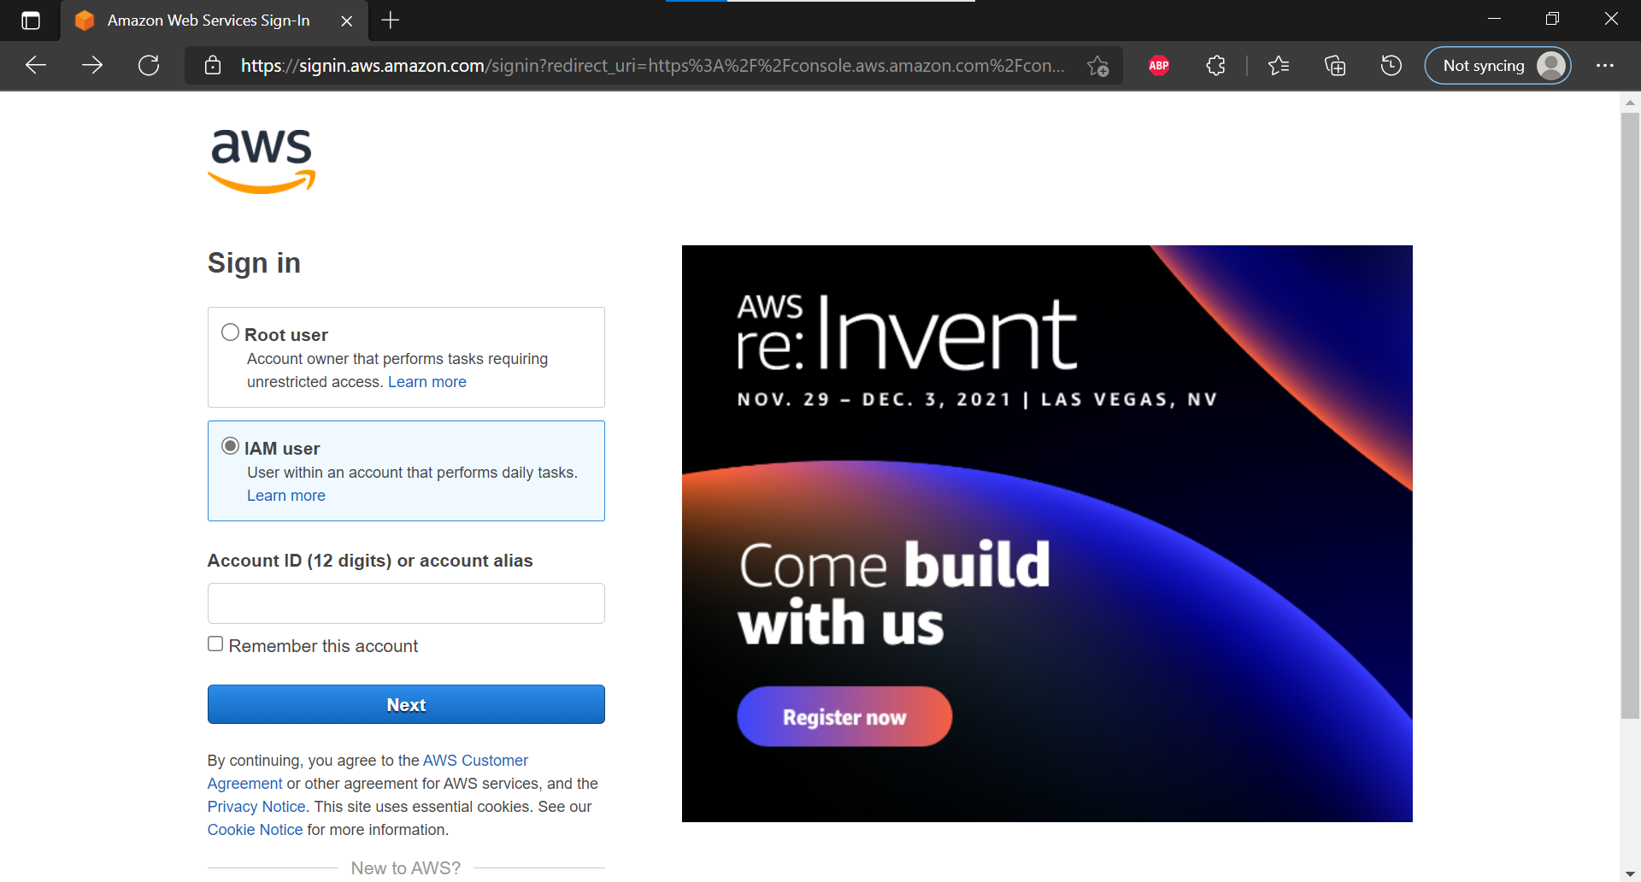

**Step 12: Find the AWS cloud9 service in the Services console.**

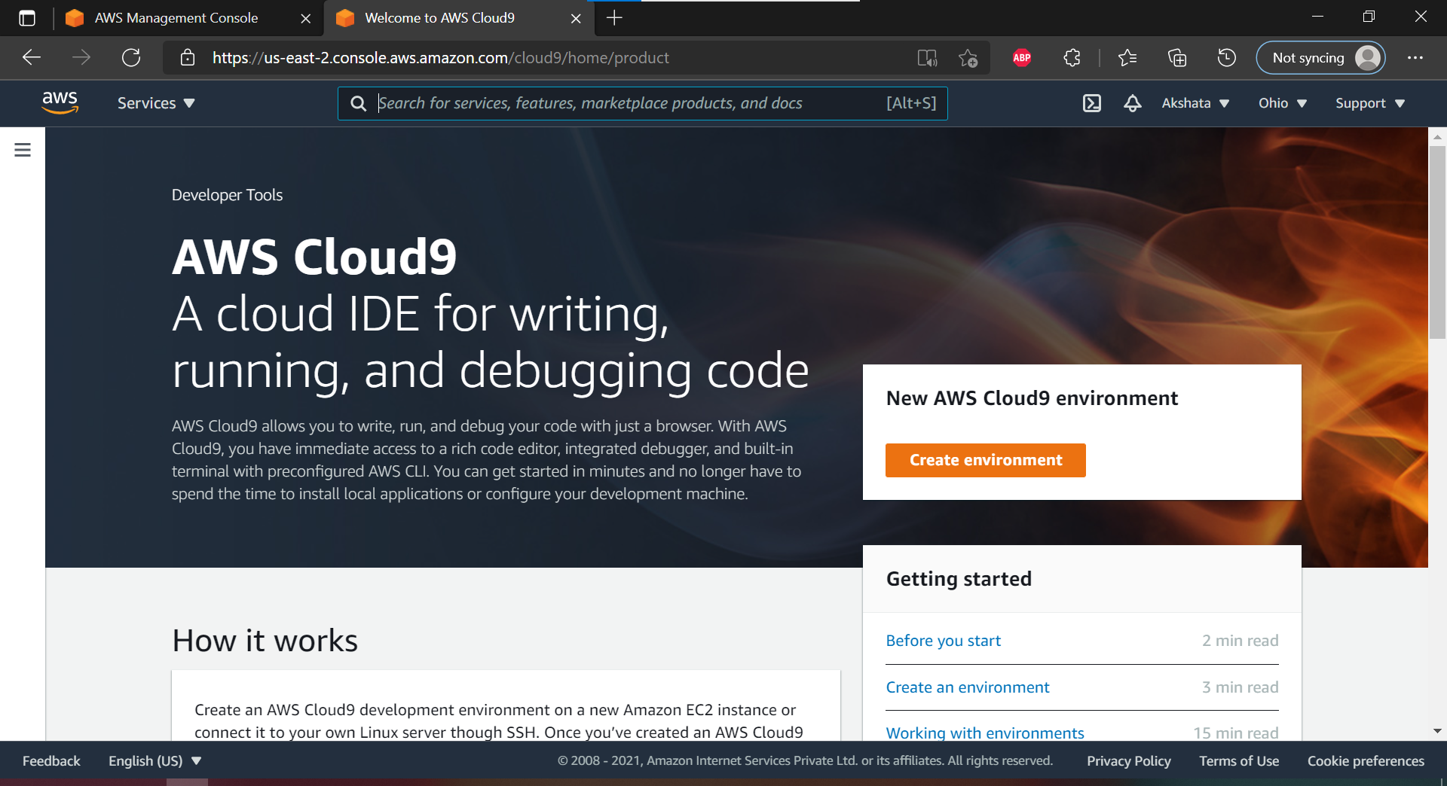

**Step 13: create an environment and provide the details for the environment as shown below**

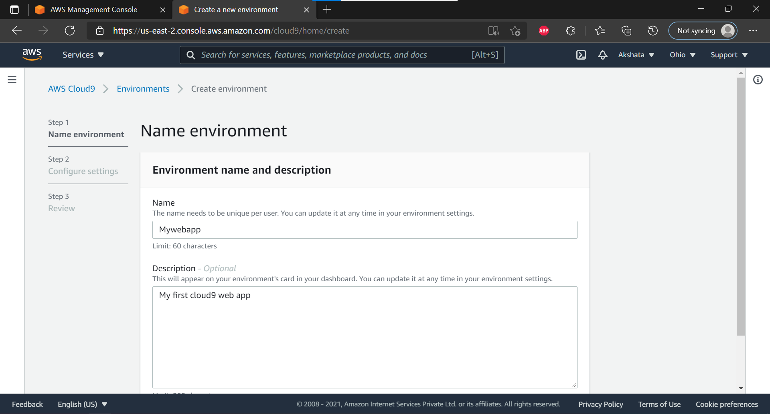

**Step 14: Keep all the default setting as given below**

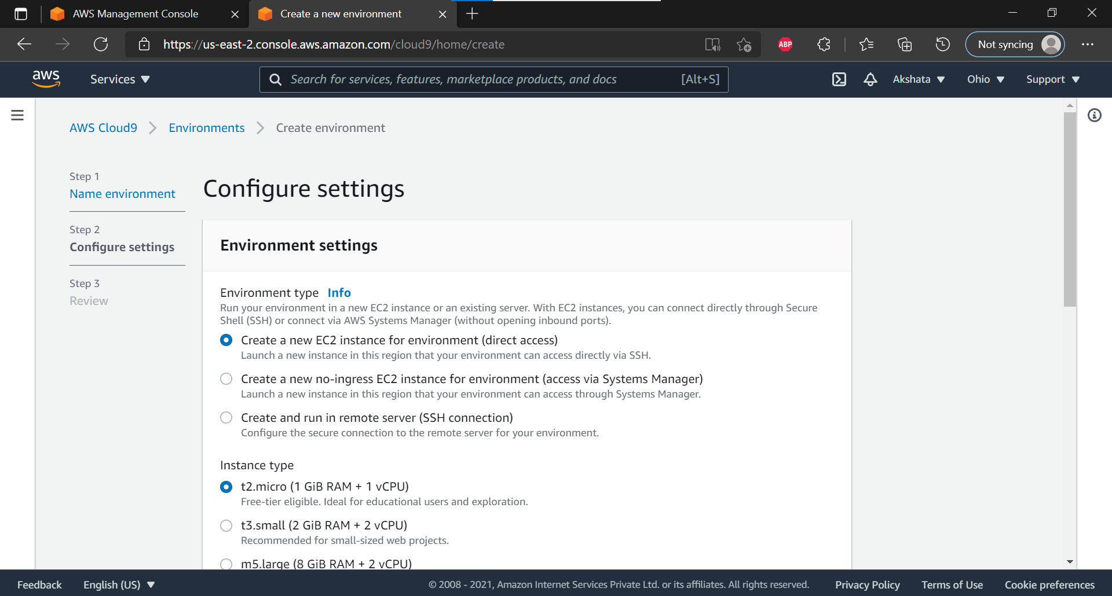

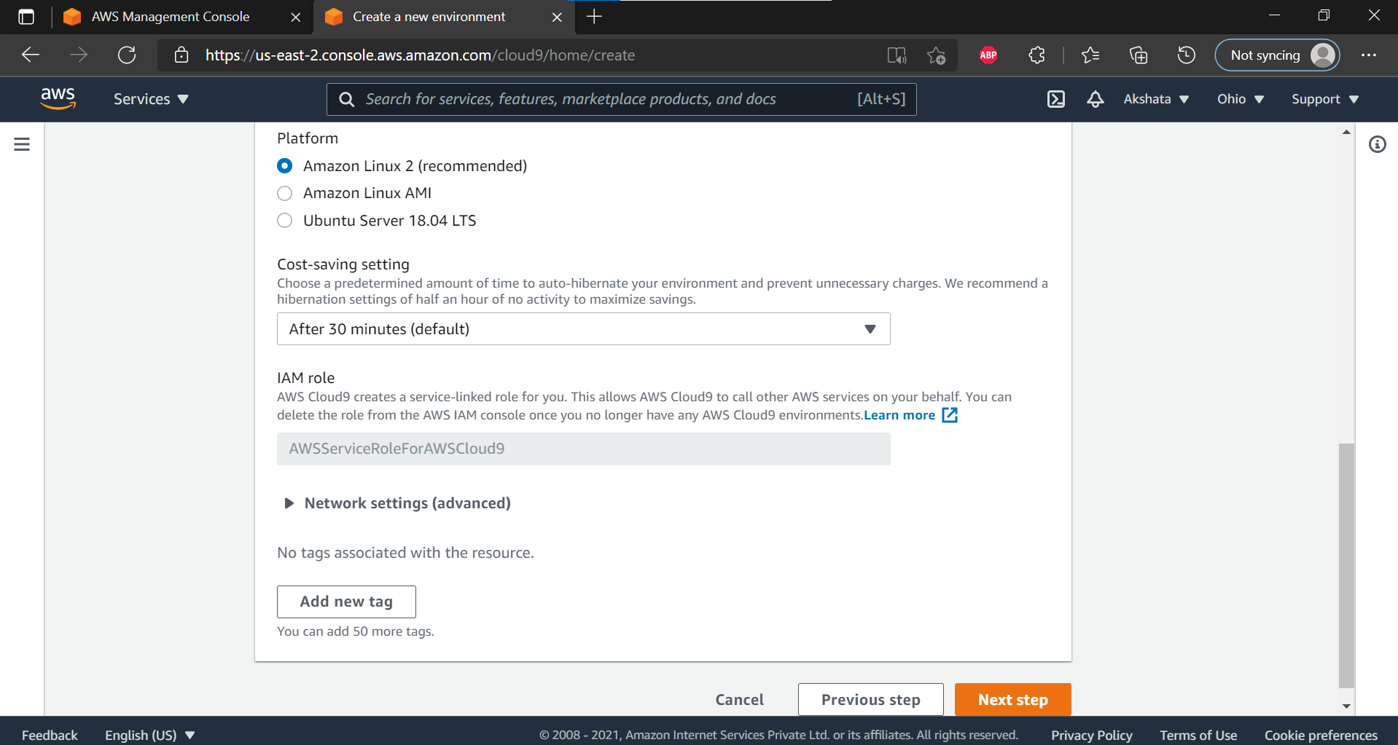

**Step 15: review the settings and create the environment.**

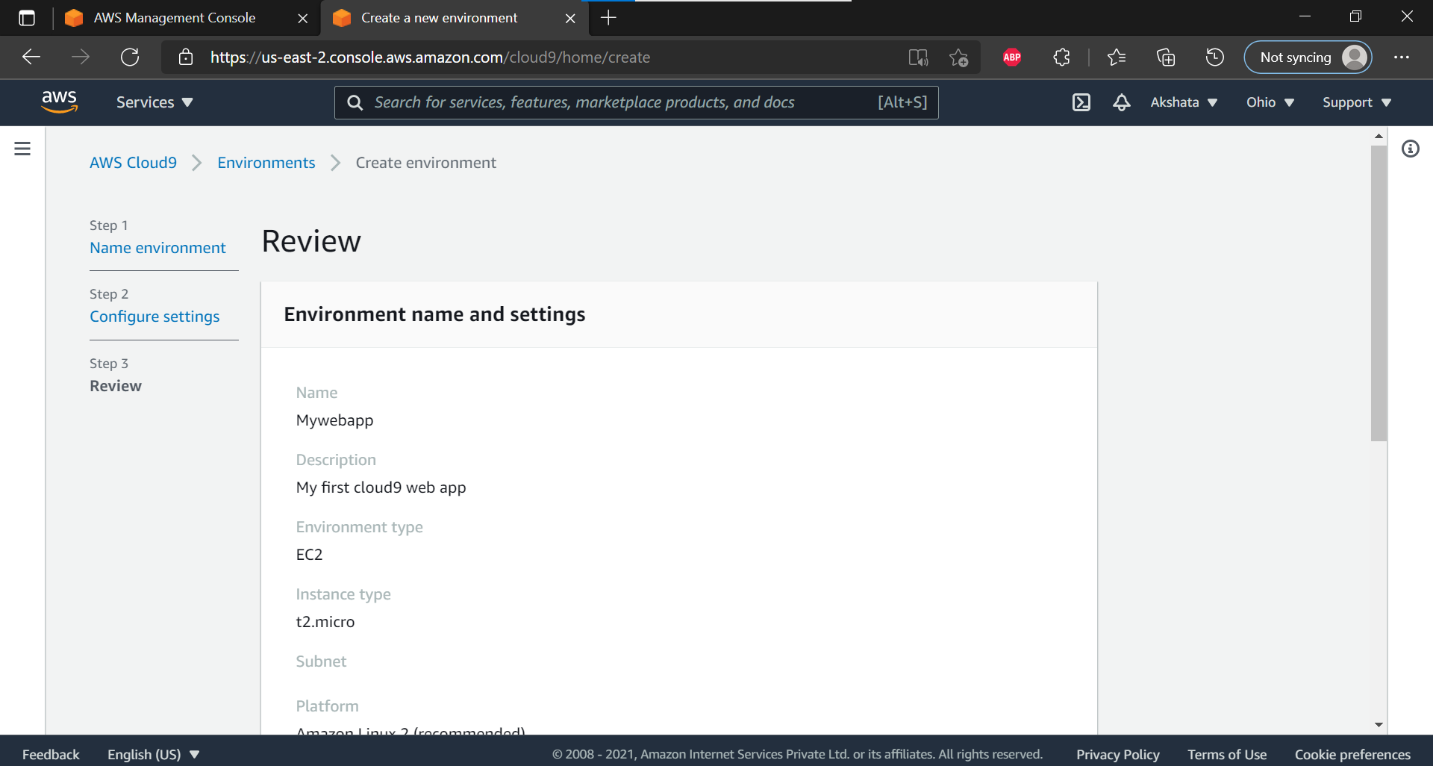

**Step 16: It will take few minutes to create aws instance for your Cloud 9 Environment**

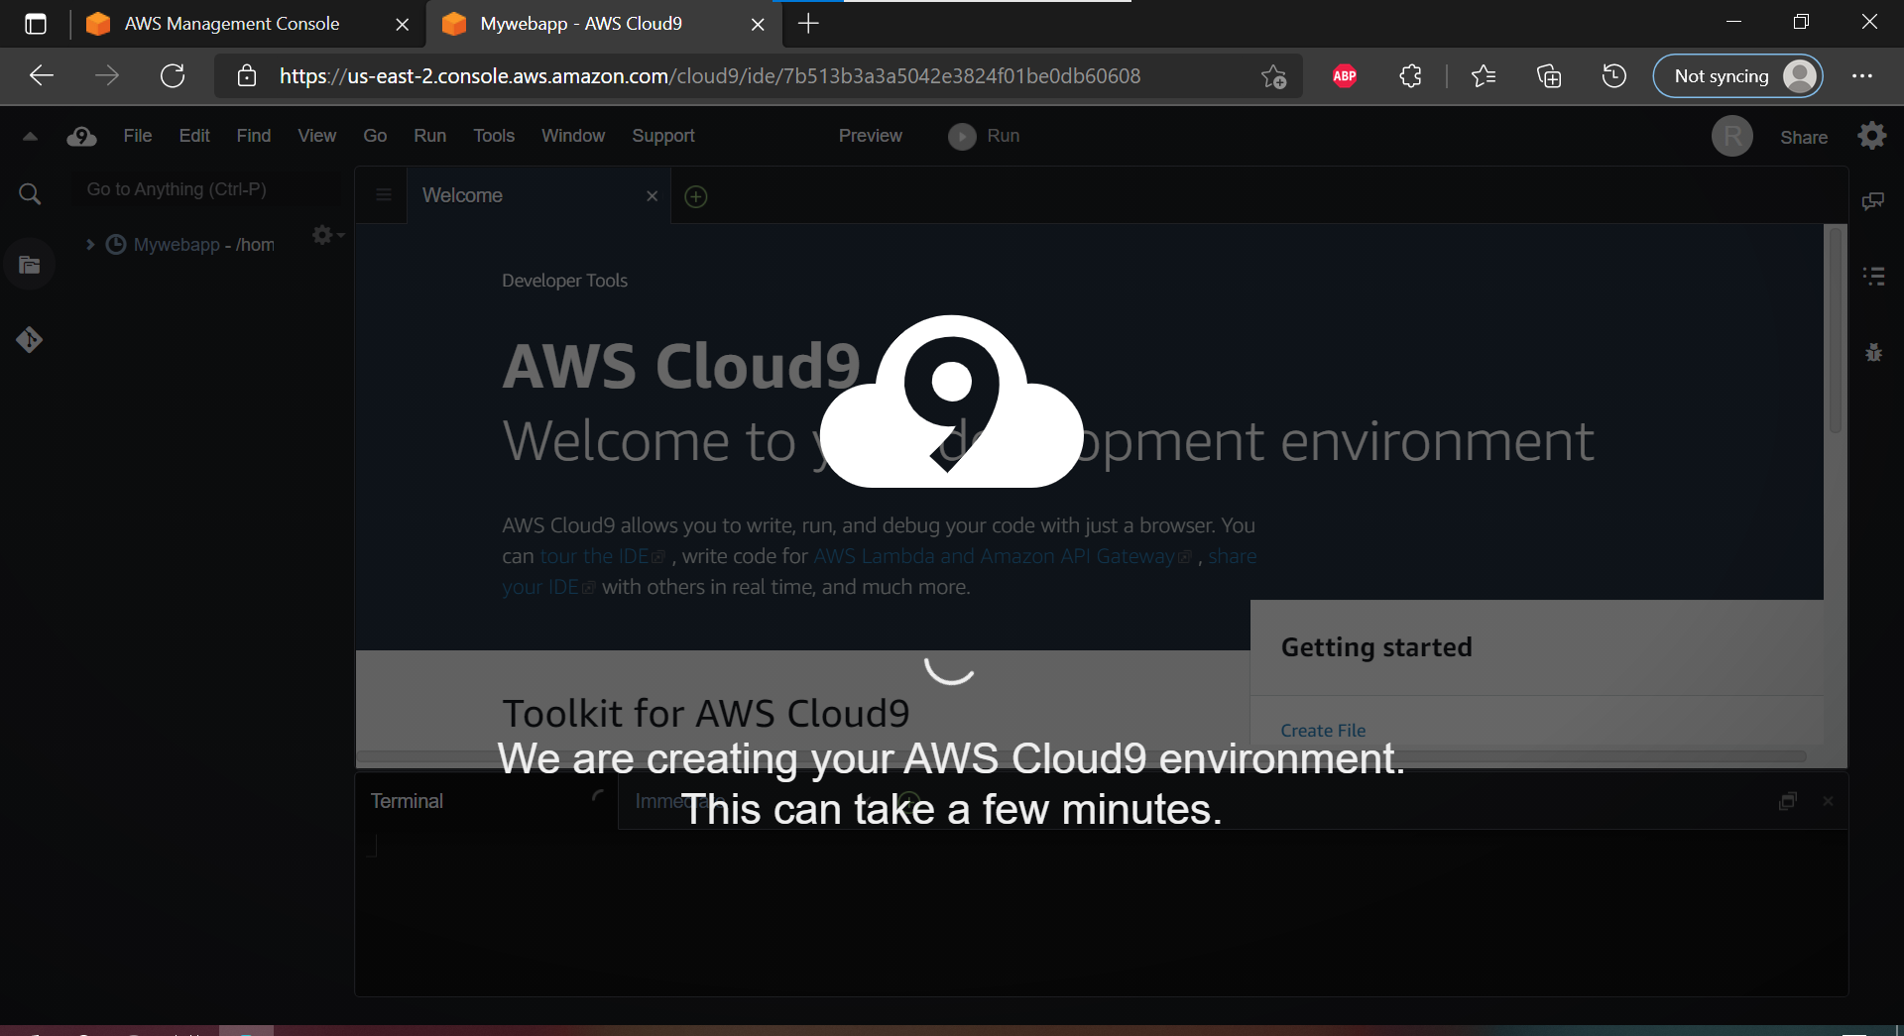

**Step 17: Open the cloud9 IDE instance and see the welcome page**

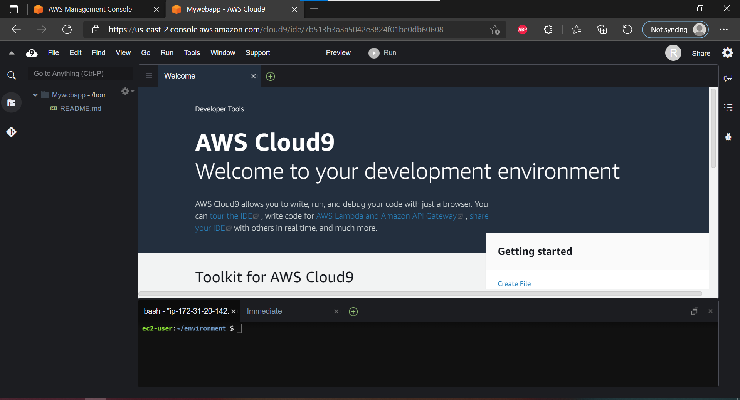

**Step18: If you check at bottom side Cloud9 IDE also giving you and aws CLI for command operations: as we here checked git version, iam user details**

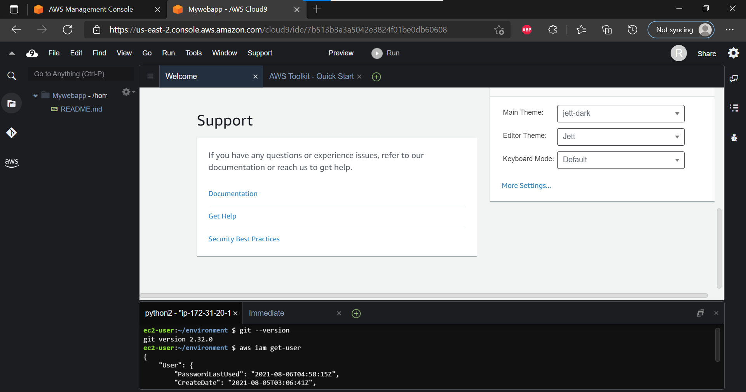

**Step 19: Upload the website folder by selecting upload local files in file section.**

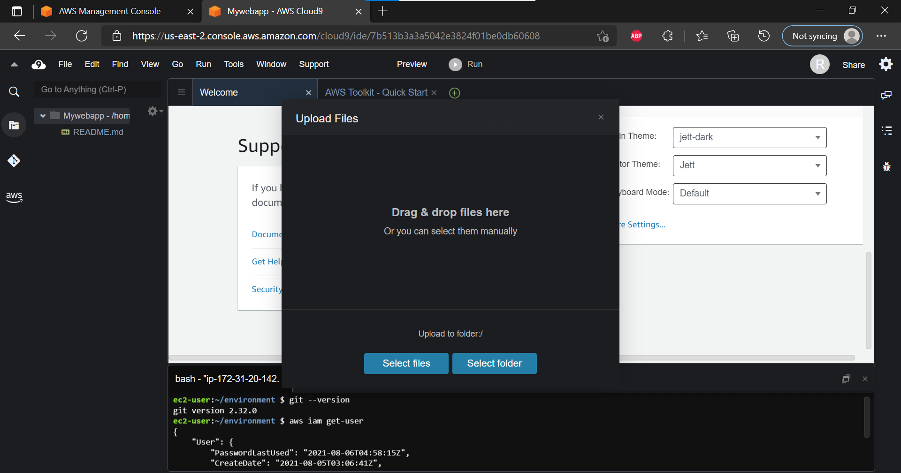

**Step 20: edit the .html file and save the changes.**

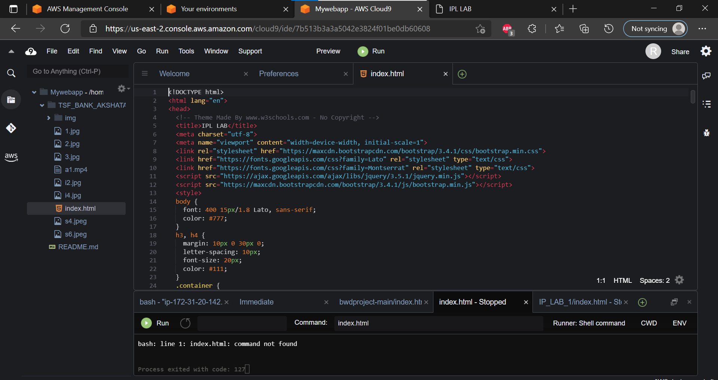

**Step 21: See the preview of index.html by selecting preview button . explore it in the browser also.**

Mahavir Education Tmp

A/fitiBlrd to Uni ity Of KfMb i, Apart by'D,T.R, & A''I•C'J'• •'•'I /toazded ‘ A’ filrrds buy D,T',F„ if, $, I R gasiCG T''ngingring Pr08rBm 0



SHAH & ANCHOe xwcssi esaiseERlNO coizeac

ISO 300 I Cccci6od

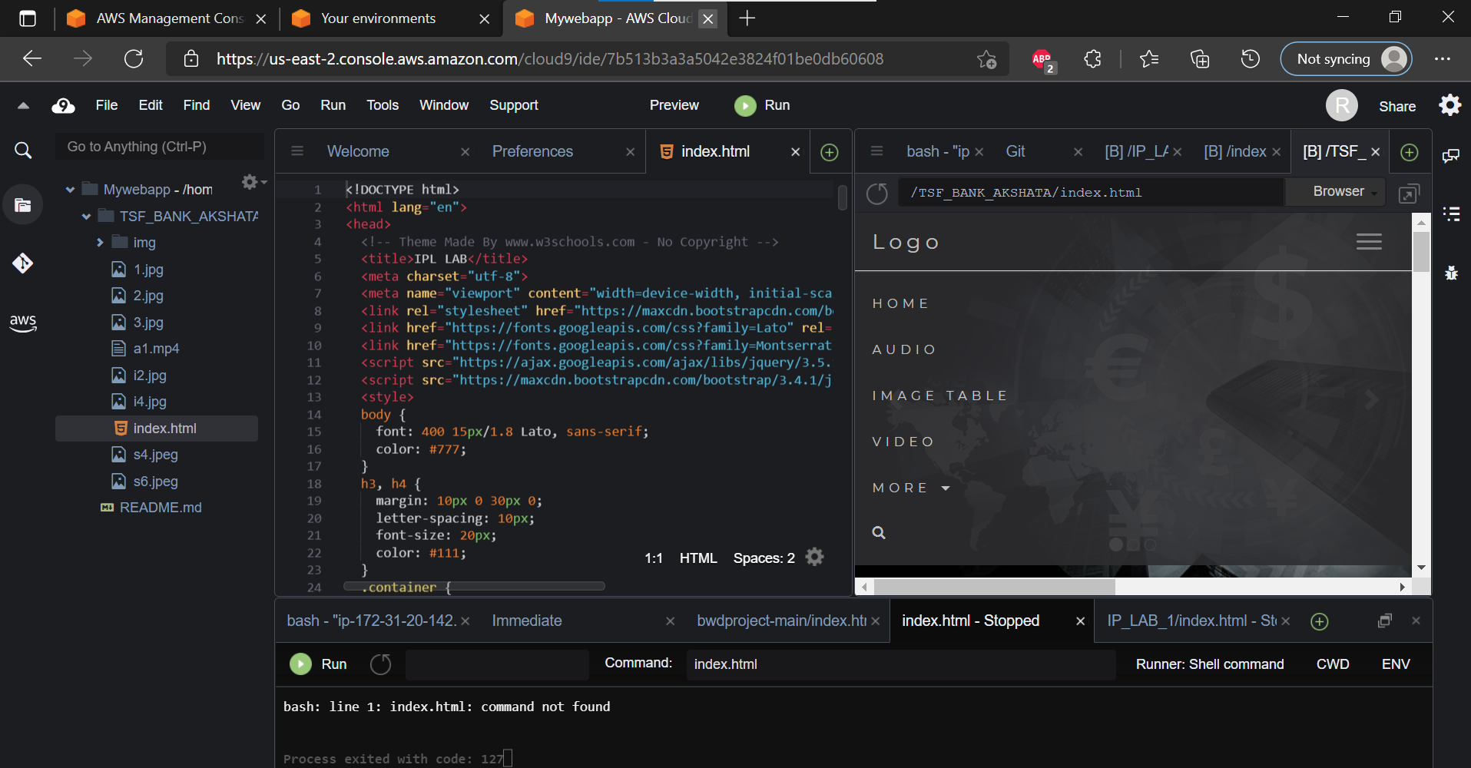

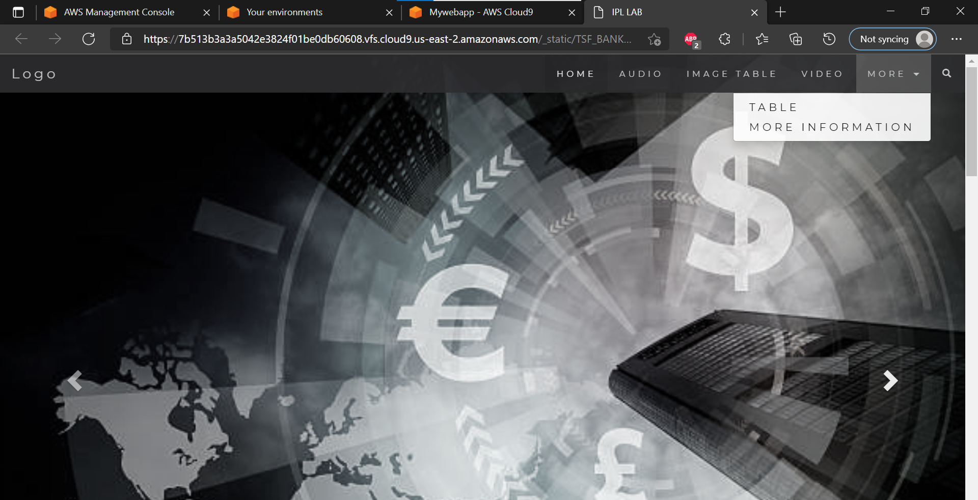

# Step 22: Create another IAM user by sign in to root user account and add user in IAM management console and follow the procedure of step 4 to Step 9.

**A new IAM user is created and credentials saved. Sign out the root account.**

**Step 23: Sign in to IAM user created initially and open the Cloud9 environment IDE**

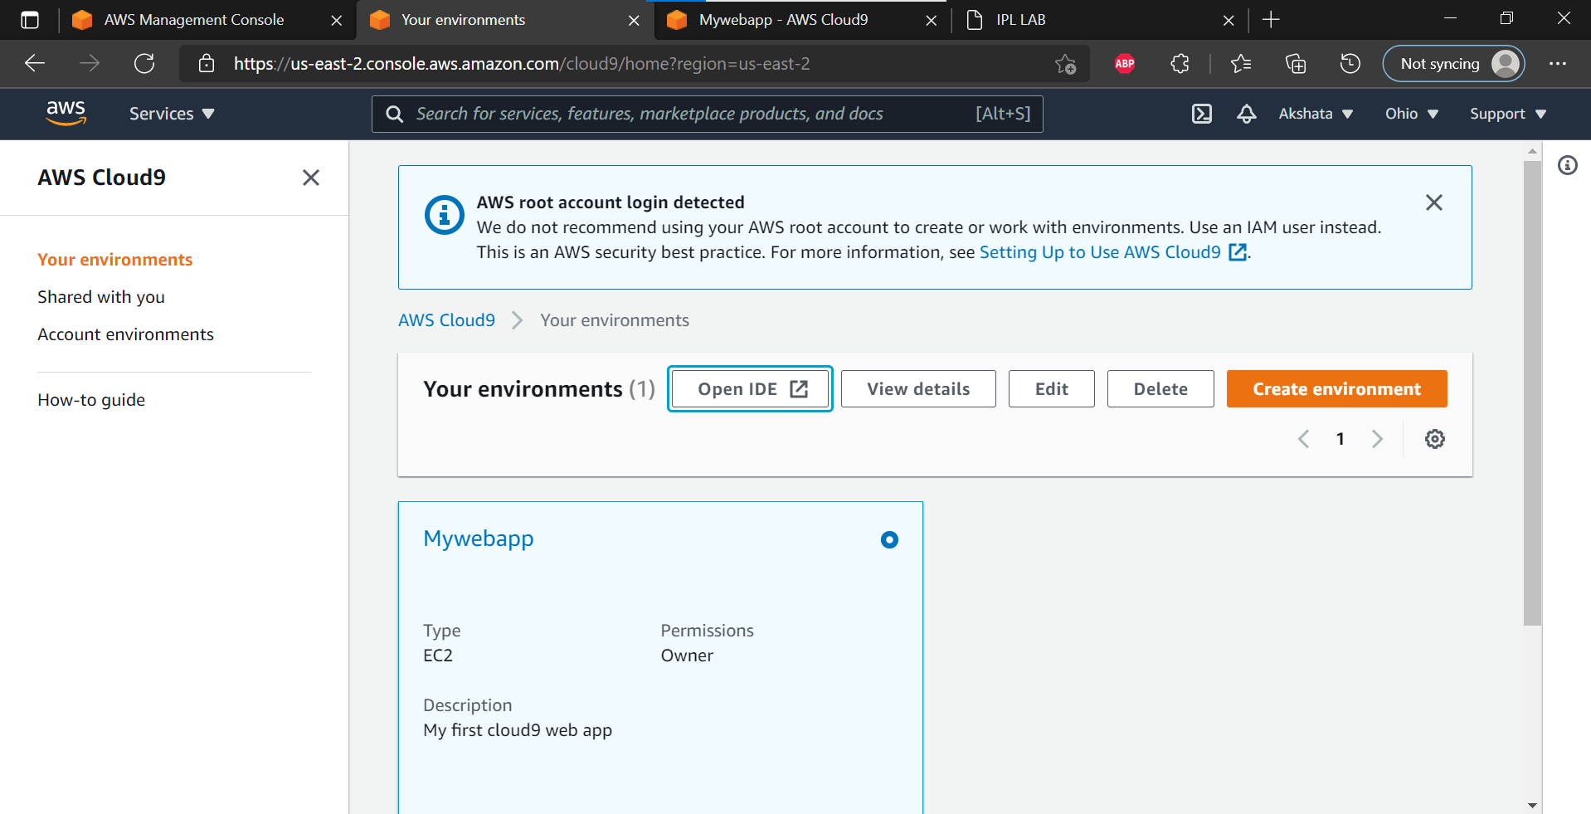

**Step 24: Click on the share button and invite the new user by providing IAM user name**

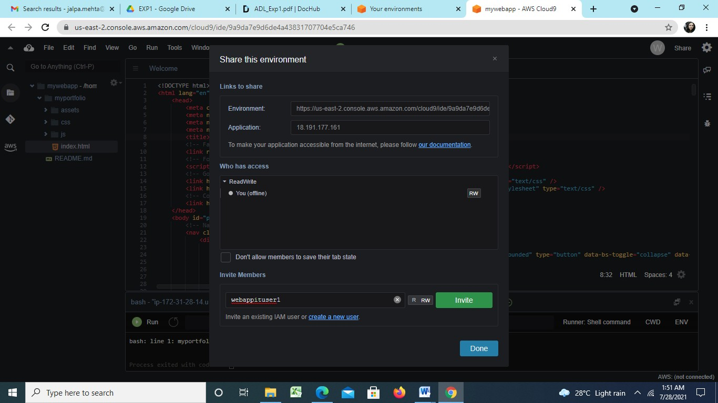

**Step 25 : Allow RW access to the user and click on ok**

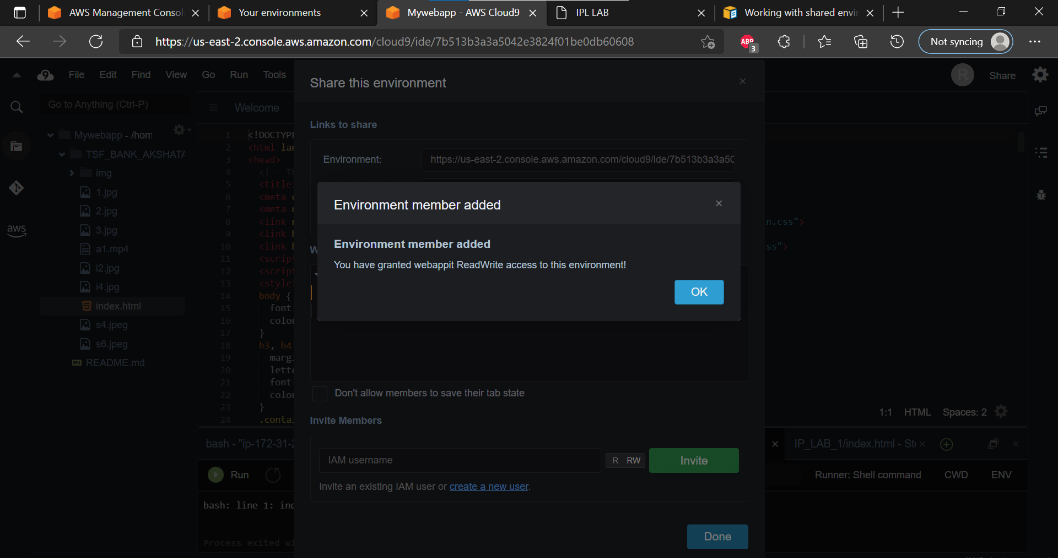

**Step 26 :Now Open your Browsers Incognito Window and login with new IAM user created.**

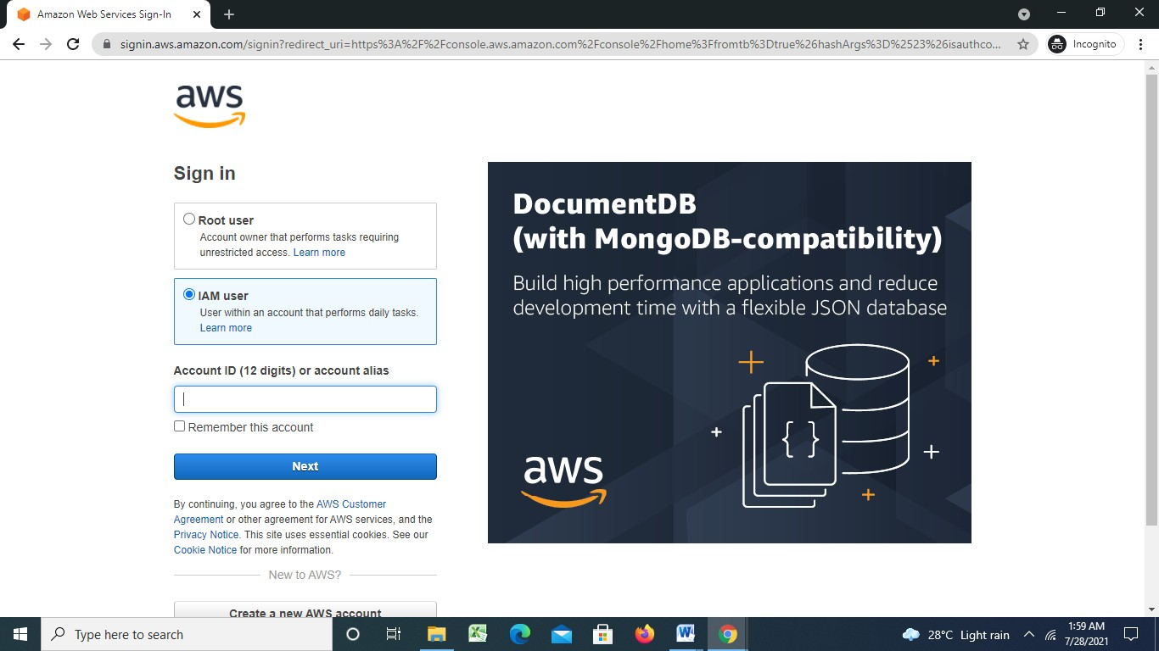

**Step 27: Go to Cloud9 service and open shared with you environment and open IDE.**

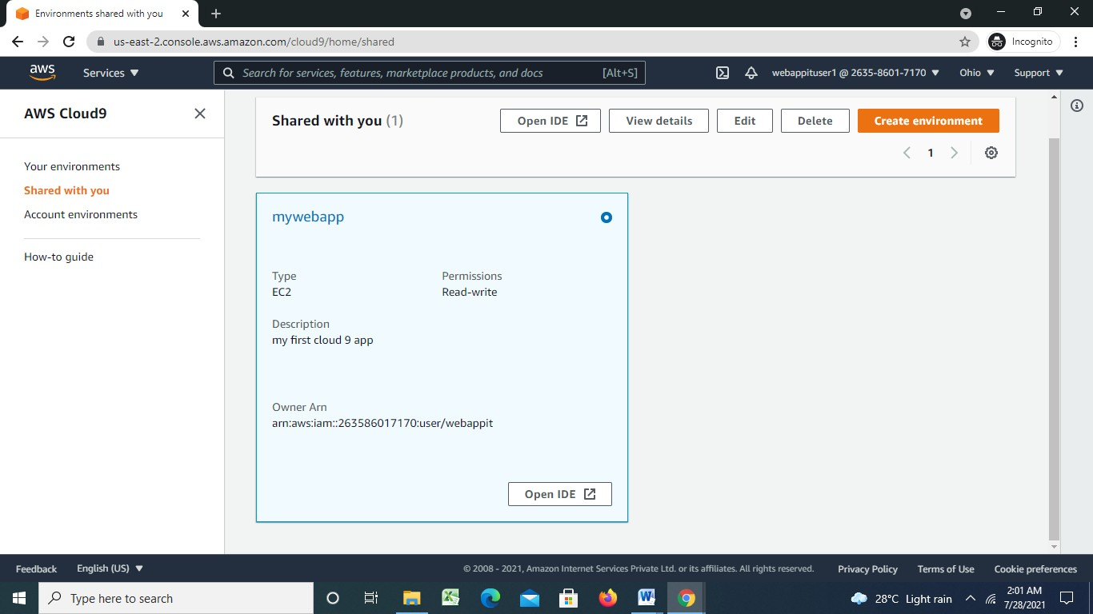

**Step 28: Open both IAM users Cloud 9 IDE together in same window**

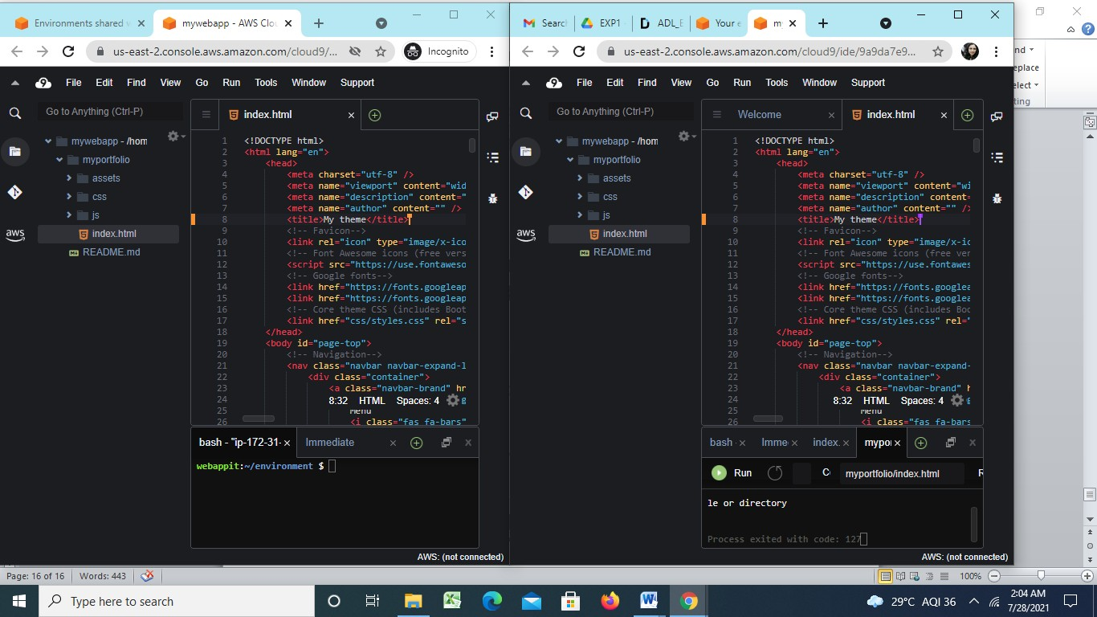

**Step 29: Edit the code in both user’s IDEs and see the changes.**





- Mahavir Education Trnas

for 3 ycas w.e.f. 1 " Jury i0 19 | Information Teohruiiogy Program Accreditated by N.B.A., New Delhi for 3 years w.c.f. I* July 20 l9

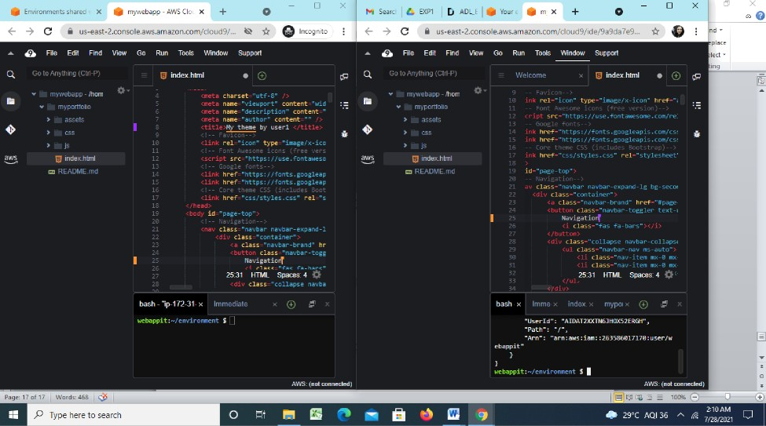

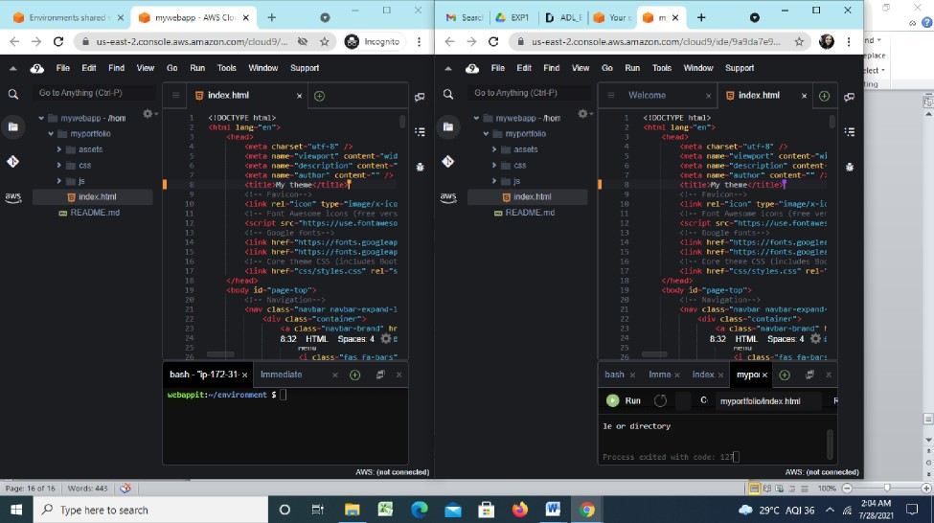

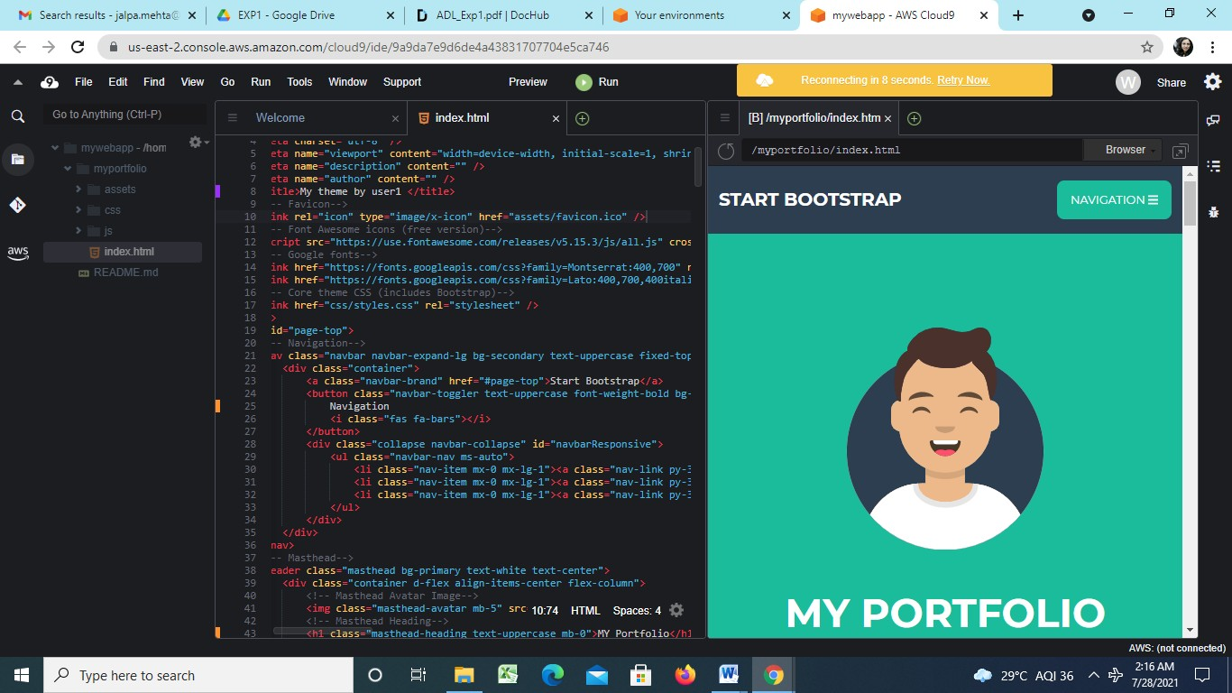

**Step 30: Also you can do group chat with in the team .**

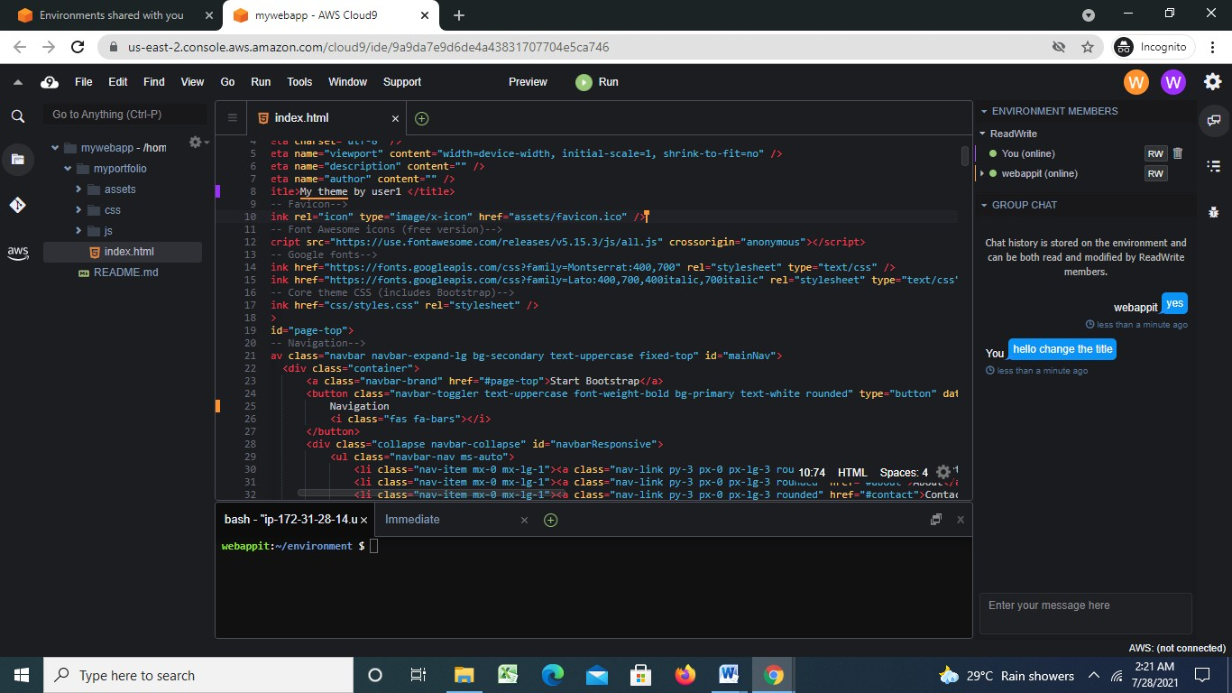

**Step 31: you can also explore settings where you can update permissions of your temmates as from RW to R only or you can remove user too**

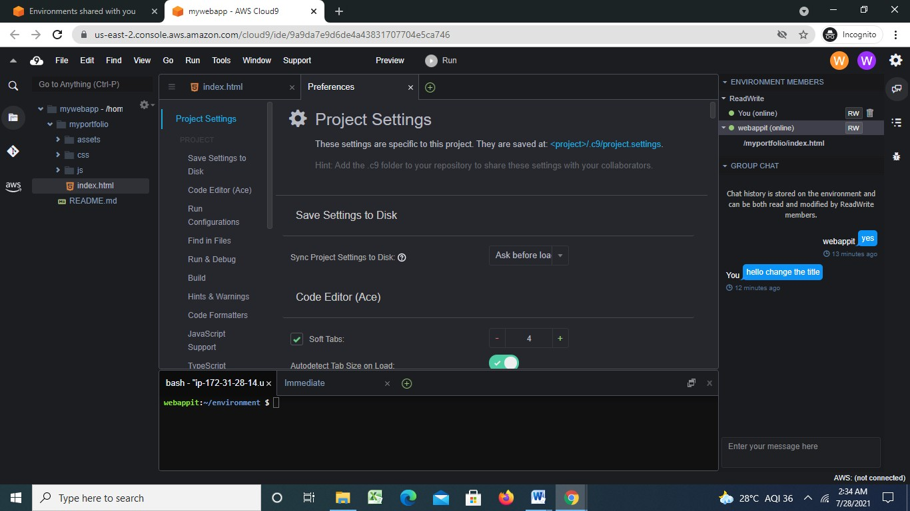

**For more info related to AWS-Cloud 9 you all can refer following Docs.**

[**https://docs.aws.amazon.com/cloud9/latest/user-guide/aws-cloud9-ug.pdf**](https://docs.aws.amazon.com/cloud9/latest/user-guide/aws-cloud9-ug.pdf)

**Conclusion:** Hence the AWS Cloud9 IDE has been set up, Cloud9 IDE has been launched and collaboration demonstration has been performed.